Professional Resourcing Team

WebExpenses
Locum User Manual
(Well Professional Resourcing Database)

NOT FOR DISTRIBUTION
This Manual contains information of a sensitive nature. Strictly for PRT reference purpose ONLY.

Contents
Page
- Introduction………………………………………………………………………… 03
- Access……………………………………………………………………………… 04
- Reviewing Claims…………………………………………………………………. 04
- Creating a New Locum User……………………………………………………… 05
- User Report……..…………………………………………………………………. 07
- Claim Report……..………………………………………………………………... 08
- Useful Links………………………………………………………………………... 09

Introduction

Welcome to WebExpenses: Well Professional Resourcing locum expenses system.

This user’s manual will guide you through all aspects of WebExpenses that are specific to you as a Locum.

The User Manual contains all essential information for you to make full use of the WebExpenses system. It includes a description of the system functions, capabilities, and step-by-step procedures for system access and use. Screenshots have been provided to ensure ease of understanding.

Users may contact the Webexpenses support team for any queries or visit their support hub for FAQs and feature videos.
https://hub.webexpenses.com/
support@webexpenses.com
+44 (0)800 711 7138

In order for you to be able to use WebExpenses you will have to be set up as a WebExpenses user by a Professional Resourcing Administrator. Your email address will have to be submitted and before any access to WebExpenses is allowed.

- Access
To access WebExpenses, use the following link in your internet browser (Chrome)
https://gb.webexpenses.com/we/
(Save this link to your favourites on your internet browser for easy future access)
When you click on this link, the following home page should appear on your screen.

Once your profile has been completed you can also download the WebExpenses app for IOS or Android phones and build/submit your expenses claims from there.

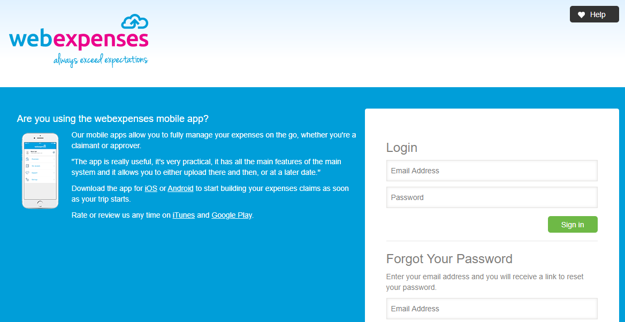

- Completing Your Profile
It’s important for you to complete your user profile as soon as you receive your WebExpenses welcome email, to do so please follow the steps below.
- Go to your Account Details in the top, right corner
- Click My Settings
- Complete the fields in the General, Vehicle, Email Alerts and Additional Information tabs

- Click Save to keep the changes.

3. Creating a claim header
Web Interface
- Log in to your Webexpenses account on the web user interface
- Now click Add to create a new claim header
- Add a Title for the claim
- Enter any relevant Notes (these will be visible to yourself and your Approvers)
- You will see your Cost Centre, your default Approver and your default Accounts Approver
- Click on Click here to define default settings to pre-populate claim item fields
- Click Save to create the claim header
- You are now ready to start building your claim.

IOS/Android
- Tap My Claims
- Now tap Add to create a new claim header
- Add a Title for the claim
- Enter any relevant notes (these will be visible to yourself and your Approvers)
- Below, you will see your Cost Centre, your default Approver and your default Accounts Approver
- Click Save to create the claim header
- You are now ready to start building your claim.

Click on this link for a video tutorial - https://hub.webexpenses.com/resource/how-to-create-a-claim-header/

4. How to add a claim item to a claim
Web Interface

- Click on the claim Title to open the claim
- Now click on the Add Item to the Claim button
- Select the expense Category for the item
- You can search here and then click to pick
- Now select the Date of the expense
- Enter the Amount of the expense
- Add a full Description of the spend
- The receipt has been located and attached, this is based on the date and the amount matching
- Click Save to keep the changes.

iOS/Android

1. Tap My Claims
2. Tap the claim that you want to add the claim item to
3. Tap Add Item at the bottom of the screen
4. Add the Date the expense took place
5. Add the Amount of the expense
6. Type in a Description for the expense
7. Select the expense Category
8. Tap Save to add the item
9. Tap Back to return to the My Claims screen
10. Tap Back again to return to the main menu

Click on this link for a video tutorial - https://hub.webexpenses.com/resource/how-to-add-a-claim-item-to-a-claim/

5. How to add a claim item to a claim
Web Interface

- From the My Claims screen, click on the Title of the claim you want to submit
- Ensure that all your claim items have a receipt attached to them where required
- Go to Actions and click on Submit in the menu
- Enter any relevant notes for your Approver and your Accounts Approver
- Now click Submit button to send your claim
- Your claim has now been Submitted to your Approver.

iOS/Android

- Tap My Claims
- Tap on the Title of the claim you want to submit
- Ensure that all your claim items have a receipt attached to them where required
- Now tap Submit at the bottom of the screen
- Enter any relevant notes for your Approver and your Accounts Approver
- And then tap Done
- Tap Submit to send your claim
- Your claim has now been Submitted to your Approver.

Click on this link for a video tutorial - https://hub.webexpenses.com/resource/how-to-submit-a-claim-for-approval/

